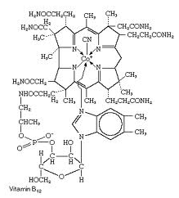 | Organic Chemistry | Name:  Date:
Lewis Structure for Carbon:

A carbon atom has _____ valence electrons.

Organic Compounds
- Contain carbon atoms usually bonded to other carbon atoms and hydrogen atoms.

  - Called _________________________________

- Organic compounds may also contain: ____________________________________________________________

Examples of organic compounds:
- Scientists thought that organic compounds contained a “life force” or “vitality.
- Was proved incorrect in 1828 when an inorganic salt was heated to produce an organic compound.

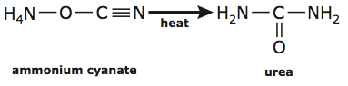

Inorganic Carbon Compounds
- Even if a compound contains carbon, it may not be classified as an organic compound.

Simple Hydrocarbons

- Recall that a carbon has _____ valence electrons.
- Each carbon atom can form _____ covalent bonds.

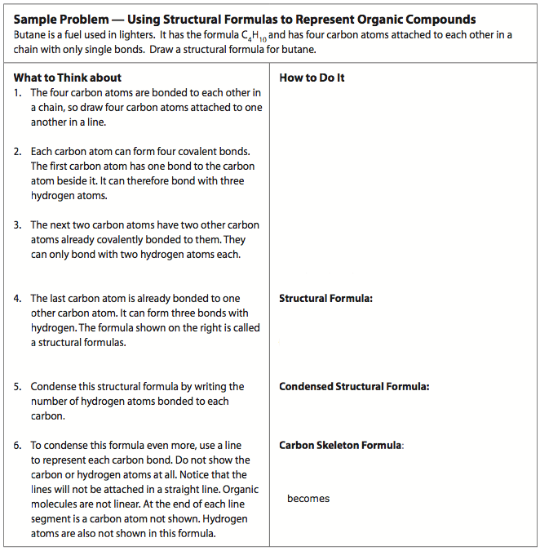

Alkanes

- Chemical Formula:

# of C Atoms | Prefix | Alkane
1
2
3
4
5
6
7
8
9
10

Problem Set:
- Write out the condensed structural formula for all 10 straight-chain alkanes.

- Draw the carbon skeleton formula for all 10 straight-chain alkanes. (You cannot draw methane.)

- Octane, a constituent of gasoline, has the molecular formula C₈H₁₈. Draw a structural formula, condensed structural formula and carbon skeleton formula for octane. Assume that the carbons are all bonded in a single chain to each other.

- Draw a structural formula, condensed structural formula, and carbon skeletal formula for C₆H₁₂. Arrange the carbon atoms in a closed ring shape so that each carbon atom is bonded to two other carbon atoms.

- What would the formula be for a straight chain alkane that had the following number of carbon or hydrogen atoms?
- 6 carbon atoms  - 12 carbon atoms  - 14 carbon atoms  - 29 carbon atoms  - 98 carbon atoms | - 102 hydrogen atoms  - 54 hydrogen atoms  - 84 hydrogen atoms  - 16 hydrogen atoms  - 4 hydrogen atoms

