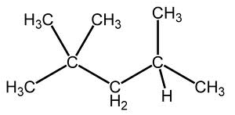 | Naming  Simple  Hydrocarbons | Name:  Date:
Steps to Naming Simple Alkanes:

- Find the ______________________________________________ of carbon atoms. It does NOT have to be in a straight line. This is called the _________________ chain.
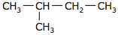 | The longest continuous chain of carbon atoms contains _____ carbon atoms
State the number of catbon atoms using the appropriate prefix and the ending “ane.”

The appropriate prefix would be _____________ and with the ending “ane” would be ______________________.

- Branches are called __________________ groups. Number the carbon atoms in the parent chain starting at the _________________________________________________.

- Name each branch.

Give a prefix according to the number of carbon atoms it contains. Branch names end in _____ instead of ___________.
List the branches in ______________________________. If more than one branch has the same number of carbon atoms use the prefixes ____________________________________________.

- Name each branch.

State the name of the alkane by naming each branch, then naming the parent. Use commas between numbers and hyphens between numbers and branches.

Practice #1.
- Parent Chain.  - Number the parent chain.  - Name the branches.  - Name the compound | 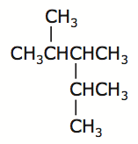
Practice #2.
- Parent Chain.  - Number the parent chain.  - Name the branches.  - Name the compound | 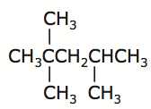
Practice #3.
- Parent Chain.  - Number the parent chain.  - Name the branches.  - Name the compound | 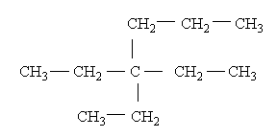

Practice #4.
- Parent Chain.  - Number the parent chain.  - Name the branches.  - Name the compound | 