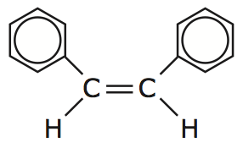 | Aromatic Rings | Name:  Date:
- Carbon atoms may bond to each other and form a ________________________________
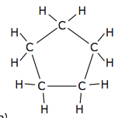 | Becomes… | 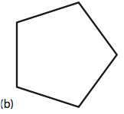

Steps to Naming Aromatic Rings:

- The ring that contains the greater number of carbon atoms is the _______________________________
- The prefix “_________________________” is placed before the parent chain name.
- Parent Chain = _______________________________

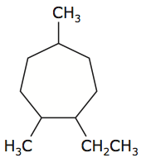

- The carbon atoms are numbered either clockwise or ________________________________________________.
- The ______________________________________ are used to identify the placement of the branches.

- Name the branches.

- Name the compound.

If the ring structure is not the longest continuous carbon chain, then it is named as a branch with prefix “cyclo” and ends in “yl.”
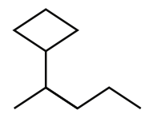
Parent: __________________________________

Branch: __________________________________

Compound: ______________________________

Practice #1
- Parent Chain.  - Number the parent chain.  - Name the branches.  - Name the compound | 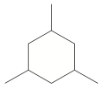

Practice #2
- Parent Chain.  - Number the parent chain.  - Name the branches.  - Name the compound | 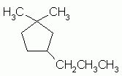

Practice #3
- Parent Chain. (remember alkene and alkyne will be main parent chain)  - Number the parent chain.  - Name the branches.  - Name the compound | 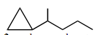

Aromatic Hydrocarbons

- Benzene is a hydrocarbon with _______________________________ atoms in a ring.
- It has the molecular formula _______________________________
- There is _____________________ than one way of drawing its Lewis structure.
- Equivalent Lewis structures are called _________________________ structures.
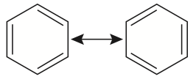
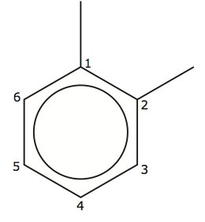Name: ________________________________

- Some organic compounds have benzene as a branch. In this case, the branch name is “_______________________________”
Practice #4
- Parent Chain. (remember alkene and alkyne will be main parent chain)  - Number the parent chain.  - Name the branches.  - Name the compound | 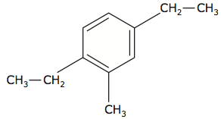
Practice #5
- Parent Chain. (remember alkene and alkyne will be main parent chain)  - Number the parent chain.  - Name the branches.  - Name the compound | 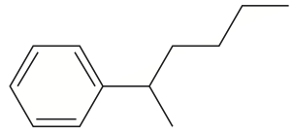
Practice #6
- Parent Chain. (remember alkene and alkyne will be main parent chain)

- Number the parent chain.

- Name the branches.

- Name the compound

