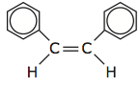 |  | Cycloalkanes |  | Name:  Date:
1. | 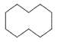
2. | 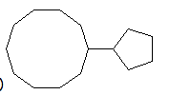
3. | 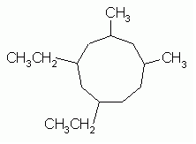
4. | 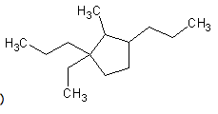
5. | 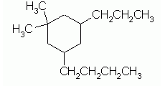
6. | 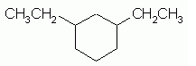
7. | 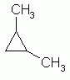

Draw the SKELETAL structural formula for the following organic compounds:

- 1,3-dipropylcyclobutane
- cyclopentane
- 1-ethyl,1,3,3-tripropylcyclobutane
- 1,2-dimethylcyclopropane
- 1,3-dipropylcyclodecane

