NOTES: HEREDITY (CLASSICAL GENETICS)
THE FATHER OF GENETICS: GREGOR MENDEL

- The first to suggest how traits were passed from parent to offspring that contrasted
the blending theory of inheritance.

- Blending Theory of Inheritance:

- How many pea plants did he experiment with over his life?
- How did he breed the plants to carry out his experiments?

Mendel explored the traits to the left. His findings led to the first understanding of what we now know as The Laws of Genetics
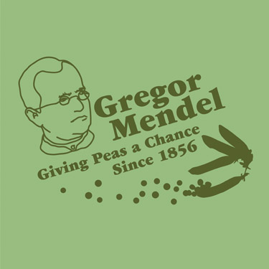

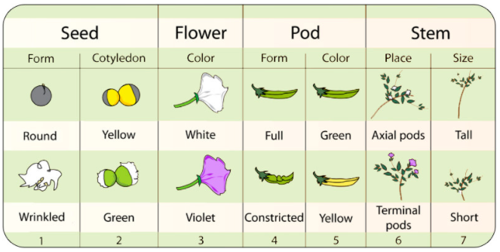

THE CELL
The cell is the basic building block of life. All organisms are made up of one or more cells. Label the parts of the cell in the diagram below using the following terms:
Cell membrane, cytoplasm, mitochondria, nucleus, nuclear membrane, nucleolus, chromatin, ribosome, vesicles, smooth endoplasmic reticulum, rough endoplasmic reticulum, Golgi apparatus, centrioles, cytoskeleton

MENDELIAN LAWS OF GENETICS
Law of Segregation | During gamete formation, the alleles for each gene separate so that each gamete carries only ______ _________________ for each gene. | 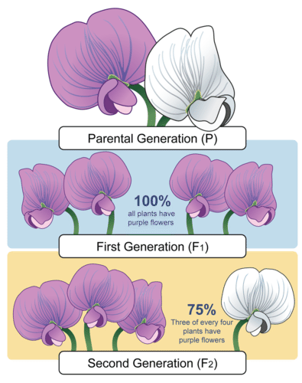
Law of Dominance | Some alleles are dominant while others are recessive; an organism with at least one dominant allele will display the ___________________________ of the ____________________ allele.
Law of Independent Assortment | When gametes form, alleles of different genes have an ______________________ ______________________ chance of combining with each other | 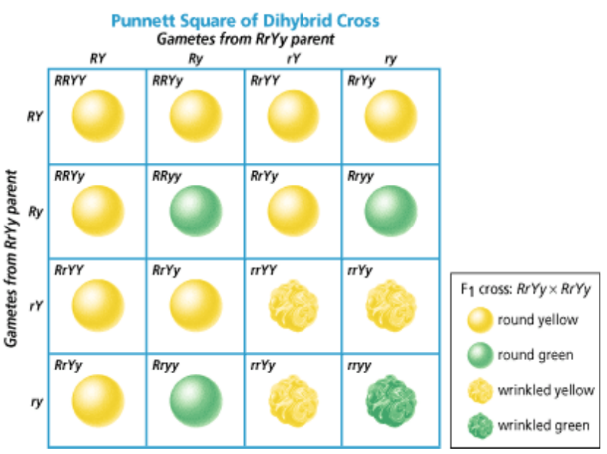
WORDS TO KNOW
Define the following terms in your own words.
Genotype | Allele
Phenotype | Homozygous (“purebred”)
Gene | Heterozygous (“hybrid”)

In this case, Y represents the gene that determines pea pod colour. The Y (yellow) allele is dominant
over the y (green) allele.
PUNNETT SQUARES:

Based on Mendels’ Laws (and what we now know through molecular genetics), we can predict what the possible traits of offspring from two parents will be, as well as the odds of the offspring having any particular trait

Steps:
- List the alleles from one parent along the top of the square
- List the alleles from the other parent along the side of the square
- Complete the chart based on which alleles are combining in which square to find out the possible combinations for the offspring

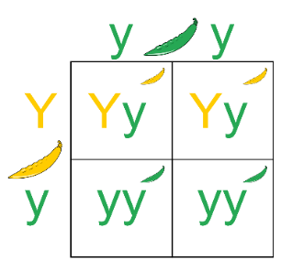
The punnet square shows the breeding of a yy plant with a Yy plant

How many offspring are yellow? _______
So, the chances of a yellow offpring are _______ %, and the chances of a green offspring are ________%

PRACTICE
In Humans, the brown eye allele (B) is usually dominant to the blue eye
allele (b). If a father that is homozygous for the brown eye allele has a
child with a mother who is heterozygous for the blue eye allele, what are
the possible genotypes of their children?

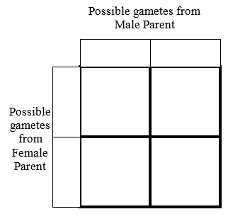
- What are the genotypes of the parents?
  - Father:
  - Mother

- What are the phenotypes of the parents?
  - Father
  - Mother

- Complete the Punnett Square to the right to show the possible genotypes of their offspring.

- What percentage chance is there for their child to have blue eyes?

