PRACTICE: NON-MENDELIAN GENETICS
FAMILIAR PROBLEMS
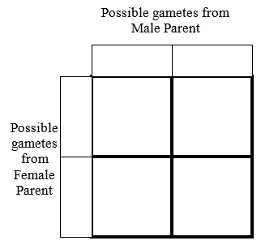
CODOMINANCE & INCOMPLETE DOMINANCE

- In certain species of chickens the allele for black feathers (B) is co-dominant with the allele for white feathers (W). Hybrid chickens (BW) have a “speckled” color with both black and white feathers. Cross two chickens that are hybrid for feather color. What are the phenotypes of the offspring? What are the percentage chances of each?

- Cat fur color is determined by codominance. The allele for tan fur (TT) and the allele for black fur (BB) are codominant. The heterozygous condition (TB) results in a cat with tan and black spots, called a tabby cat. What would occur is a tan cat was crossed with a tabby cat? Draw the Punnett square and identify the percentage chance of each genotype and phenotype of their offspring.

If two tabby cats are crossed with each other, what is the likelihood that they’ll have a tabby kitten? A black kitten?

- In humans, hair type is determined by incomplete dominance. Some people have curly hair (CC), some people have straight hair (SS), and heterozygotes have wavy hair (CS). What would occur if a person with wavy hair had a baby with a person with straight hair? Draw the Punnett square and identify the percentage chance of each genotype and phenotype of their offspring.

- If two people with wavy hair have a baby together, what is the likelihood that they’ll have a curly haired baby?

What is the likelihood they’ll have a straight-haired baby?

MULTIPLE ALLELES
- Identify the blood type that would result from each genotype

I^{A}I^{B}
I^{A}i
I^{B}I^{B}
ii
I^{B}i

- A man with type AB blood is married to a woman also with type AB blood. What blood types will their children have? What are the ratios of different phenotypes?

- A man has type B blood (genotype I^{B}I^{B}) is married to a woman with type O blood. What blood types will their children have? What will the genotypes of the children be?

- A woman with type A blood (genotype I^{A}i) is married to a type B person (genotype I^{B}i). What proportion of their children will have: A blood? B blood? O blood?

- A man with type AB blood is married to a woman with type O blood. They have two biological children and one adopted child. Jane has type A blood, Bobby has type B blood, and Grace has type O blood. Which child was adopted?

X-LINKED INHERITANCE

- A man with normal vision marries a women who also has normal vision. One of their sons is colorblind. Show the cross that produced this child.

- A woman who is colorblind is married to a man with normal vision. The couple goes to a genetic counselor and asks him if any of their children will be colorblind. What would you tell them if you were the genetic counselor?

- In a large family in which all the daughters have normal vision and all the sons are colorblind, what are the probable genotypes of the parents?

