GENETICS - PEDIGREES
Pedigrees are charts that show the inheritance of a certain trait through a family. Pedigrees allow us to identify if a trait follows a specific inheritance pattern:
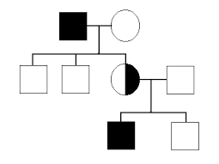
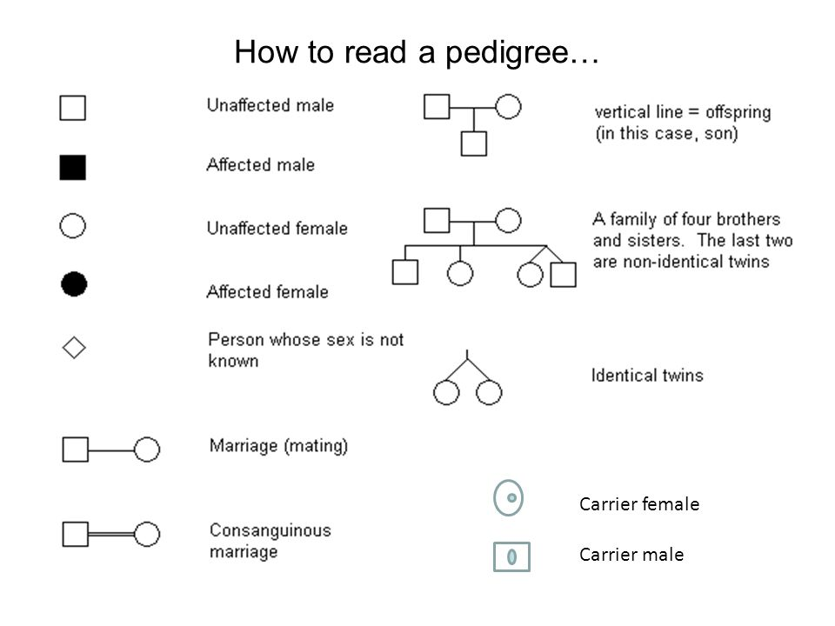
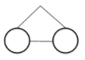
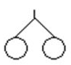
Fraternal Twins

In the pedigree above,
- How many males are there?
- How many females are there?
- How many children does the first couple have?
- Why do you think only the males are affected?

PRACTICE: DRAWING PEDIGREES
In the box, draw a pedigree for a man and a woman with 4 children.
Of the children:
- 3 are males and 1 is female
- 2 of the males are identical twins
- The 3 males are affected and the female is a carrier
- The mother is a carrier
- The father is unaffected
USING PEDIGREES TO IDENTIFY INHERITANCE:
Discuss: How can two straight-haired adults have a curly haired child?

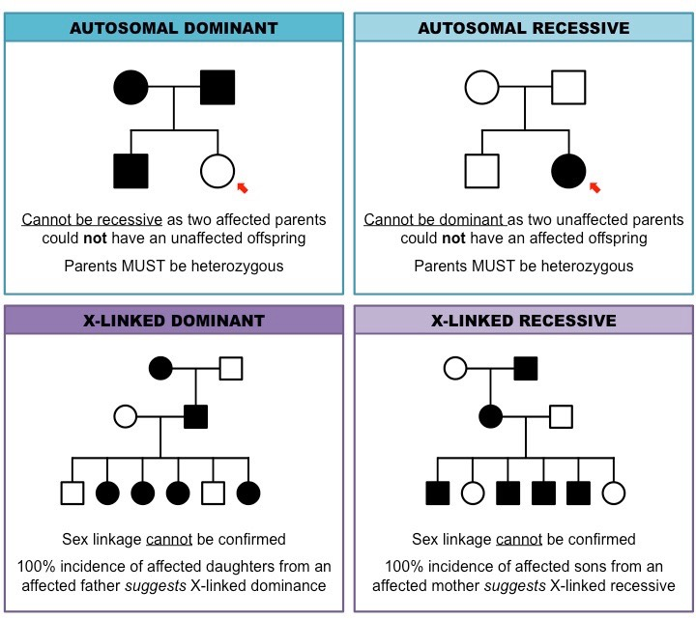
Pedigrees can give us clues to whether a trait is autosomal (on any chromosome) or sex-linked (on the X chromosome). Look for these patterns:
TRY THIS:
Identify the type of inheritance most likely in each pedigree:
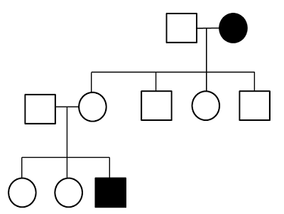
Type of Inheritance:
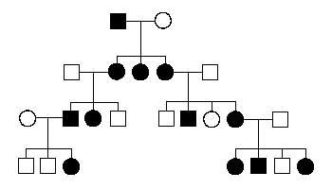
Type of Inheritance:

Does not skip a generation
At least one parent is affected
May skip a generation
Two unaffected parents can create an affected offspring
Does not skip a generation
More common in females than males
May skip a generation
More common in males than females

