UNIT 1.1 NOTES: THE CELL
Genetics
the study of characteristics of organisms and how those characteristics are controlled & passed from one generation to the next.

THE CELL
The cell is the basic building block of life. All organisms are made up of one or more cells. Label the parts of the cell in the diagram below using the following terms:
Cell membrane, cytoplasm, mitochondria, nucleus, nuclear membrane, nucleolus, chromatin, ribosome, vesicles, smooth endoplasmic reticulum, rough endoplasmic reticulum, Golgi apparatus, centrioles, cytoskeleton

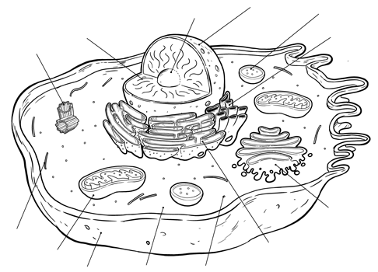

CELL STRUCTURES & GENETICS
Certain cell structures are very important in the study of genetics. These cell structures are those closely involved with DNA and proteins. Describe the structure and function of each cell part below.
 | STRUCTURE | FUNCTION
Nucleus
Nucleolus
Chromatin
Chromosomes
Ribosomes
Rough Endoplasmic Reticulum
Golgi Apparatus
Centrioles
Cytoskeleton

