UNIT 1.2 NOTES: INTRO TO GENETICS

Genetics
the study of characteristics of organisms and how those characteristics are passed from one generation to the next.

Label the following diagram using the terms: chromosome, cell, nucleus, DNA, nucleotide, gene
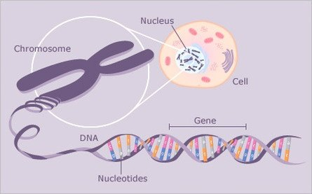

A gene is a specific sequence of in a that instructs to the cell to make proteins

Genes determine a lot of how an organism . The combination of genes in an individual result in a specific genotype and phenotype for that organism
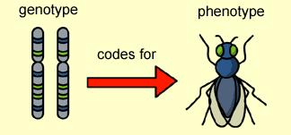

Use the image above to describe the difference between an organism’s genotype and its phenotype
GENOTYPE | PHENOTYPE
Each of your 23 individual contains specific genes

Because you inherited one copy of each chromosome from each of your parents, you have “duplicates” of each chromosome (46 total), and therefore 2 copies of each gene.

Often, the version of a gene you get from one of your parents won’t be the same as the version you inherit from your other parent.

