NOTES: DNA, GENES, AND CHROMOSOMES
Genetics
the study of characteristics of organisms and how those characteristics are controlled & passed from one generation to the next.

THE CELL
The cell is the basic building block of life. All organisms are made up of one or more cells. Label the parts of the cell in the diagram below using the following terms:
Cell membrane, cytoplasm, mitochondria, nucleus, nuclear membrane, nucleolus, chromatin, ribosome, vesicles, smooth endoplasmic reticulum, rough endoplasmic reticulum, Golgi apparatus, centrioles, cytoskeleton

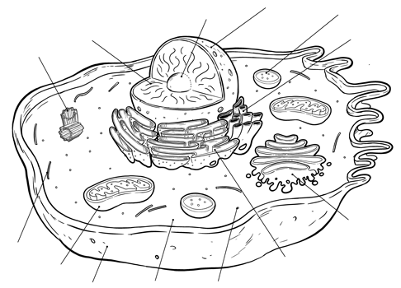

CELL STRUCTURES & GENETICS
Certain cell structures are very important in the study of genetics. These cell structures are those closely involved with DNA and proteins. Describe the structure and function of each cell part below.
 | STRUCTURE | FUNCTION
Nucleus
Nucleolus
Chromatin
Chromosomes
Ribosomes
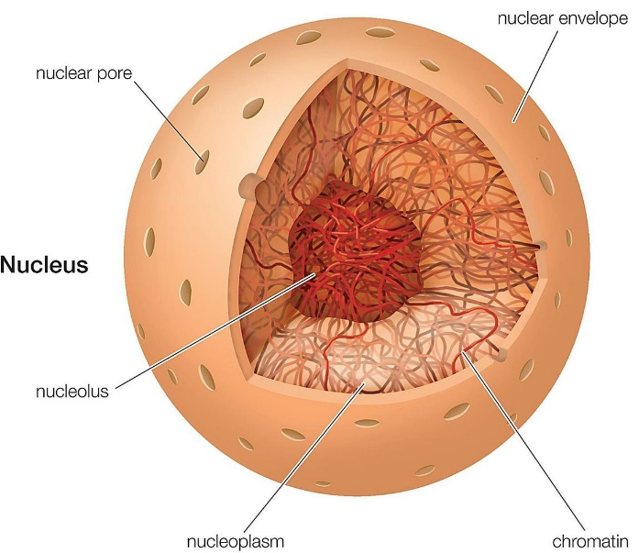
CHROMOSOMES & DNA
DNA, or ____,
is the biological molecule that houses our genetic information.
- DNA is stored in the nucleus in the form of chromatin.

- Chromatin condenses into when the cell needs to replicate. Chromosomes are easier to split to the new cell during mitosis or meiosis.
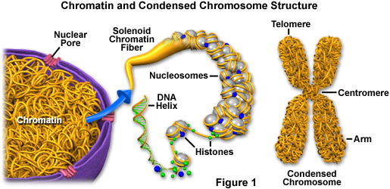

STRUCTURE OF DNA
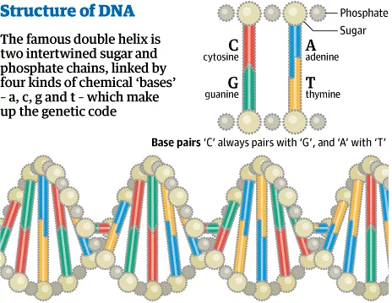
Label the diagram using the following terms:
nucleotide, nitrogenous base, sugar-phosphate backbone,
base pair, double helix

Using the terms above, describe the structure of DNA in the space below.

NUCLEOTIDES
DNA is made up of many nucleotides connected together. A nucleotide is the basic unit of DNA, and includes the following components:
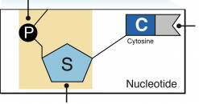
- 5-sided sugar (deoxyribose)
- Phosphate group
- Nitrogenous base

Label the three parts of the nucleotide in the image to the right.

NUCLEOTIDES (CONT.)
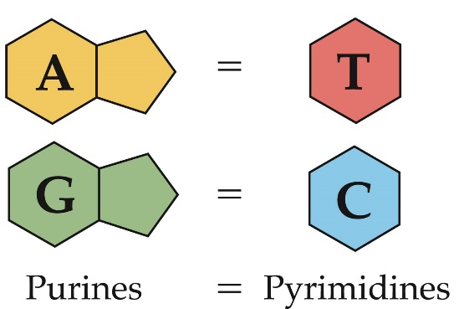
There are four nitrogenous bases that can occur in a nucleotide:

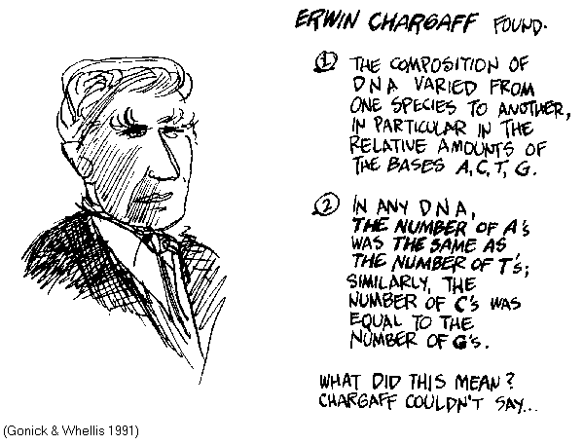
These nitrogenous bases bond with each other and form “pairs” according to Chargaff’s Rule:

DNA, GENES, AND CHROMOSOMES

How does our DNA control who we are and how we look?

The of bases in DNA is very important, just like the sequence of letters in a word or sentence is very important! Certain sections of DNA contain specific sets of instructions that control how we look and function!
DNA, Genes and Chromosomes: An Analogy
The nucleus is like a for how to make a human.
Inside the library are . These books are like .
Each book contains printed text. The text is like .
The text is organized into . Chapters are like
The chapters contain sentences made of . The words are like
Each word is made up of . The letters are like

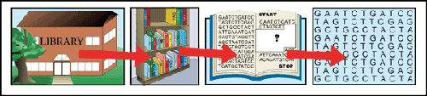
In the diagram, label the following: chromatin, chromosome, codon, DNA helix, gene, nucleotide.

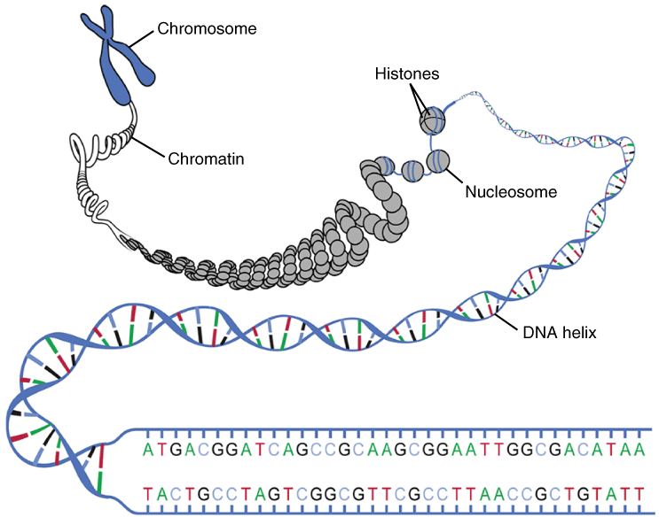

Now use those same terms to fill in the blanks below:
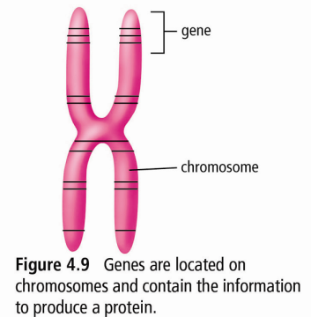
The bases in a gene that are grouped in sets of three
Small components that make up DNA
Sections of DNA that control particular characteristics
Molecule containing genetic information of an organism
DNA wound into a thin threads
Chromatin that has been condensed

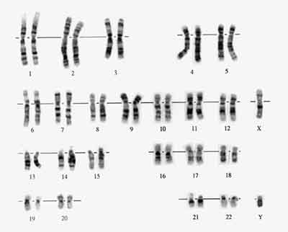
CHROMOSOMES IN ORGANISMS
All organisms on earth store their genetic information in the form
of chromosomes
- Every organism has a different number of chromosomes.

  - Cows:
  - Dogs:
  - Worms:
  - Mulberry plants:

- Chromosomes exist in pairs
- In each pair, one chromosome came from a female parent, and the other came from a male parent.
- Humans have chromosomes (23 pairs)
- Each chromosome stores different genes

