**NOTES: GENES CODE FOR PROTEINS**

The genes on your chromosomes are specific instructions for making different proteins

Gene for making earwax

Gene for eye colour

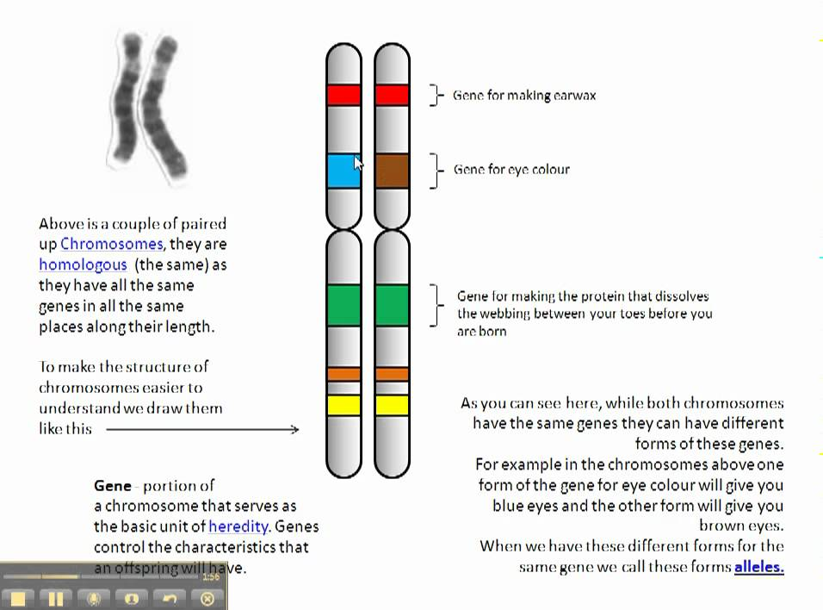

Gene for making the protein that dissolved the webbing between your toes before you are born

**Above, you can see a pair of chromosomes. They are “homologous” (the same) as they have all the same genes in the same places**

**PROTEINS DO ALMOST EVERYTHING IN YOUR BODY!**

* Structural  
  *(hair, nails, bones, muscles, blood vessels, ligaments)*
* Functional   
  *(enzymes, transportation, antibodies, cell parts)*
* Other examples to the right

**_______________**

**code for** **_______________**

**HOW PROTEINS ARE MADE**

Examine the diagrams to the left and discuss the following questions with your partner(s). Write your answers below:

*What is the process of “copying” the DNA message into RNA called?*

*Where does it occur in the cell?*

*How does the copied information get to the ribosome?*

*What is the process of using genetic information and turning it into a protein called?*

*Where does it occur in the cell? (include site and structure)*

*Why might the cell make a copy of DNA instead of having it go straight to the ribosome?*

The “central dogma” of biology: **Protein Synthesis**

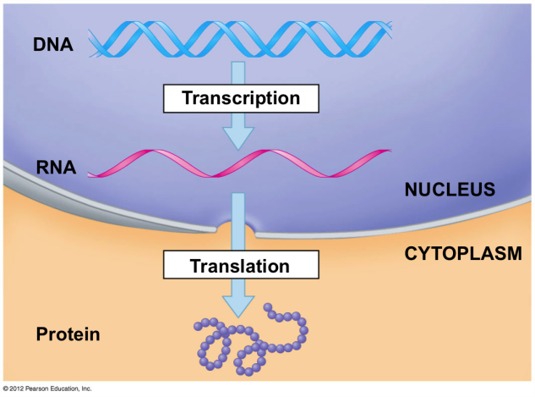

**(MADE AT RIBOSOME)**

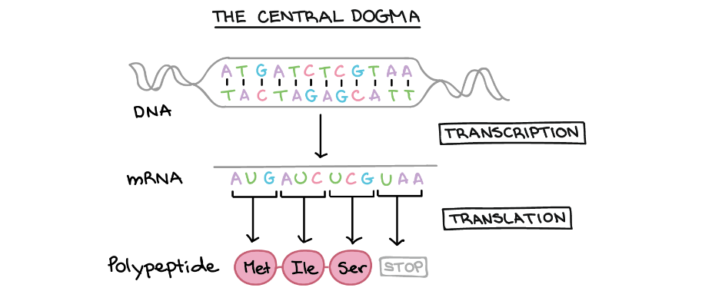

:

**HOW PROTEINS ARE MADE (CONT.)**

**Try it!** *Complete the simulation at* [*http://learn.genetics.utah.edu/content/basics/transcribe/*](http://learn.genetics.utah.edu/content/basics/transcribe/) *and answer the following questions as you go:*

1. How are the 4 bases in RNA different from the 4 bases in DNA?

**Sequence of the DNA strand:**

___

**Sequence of the mRNA strand:**

___

*Circle each codon, starting with (AUG) above*

**Sequence of amino acids:**

1. How many bases are in a “codon”?
2. What does each codon “code” for?
3. What is made at the end of the process?
4. How many different common amino acids are there in the body?
5. How many possible proteins could be made from a chain of just 7 different amino acids? ___________________________

STEPS OF PROTEIN SYNTHESIS



**(MADE AT RIBOSOME)**

|  |
| --- |
| **Transcription**   1. DNA ____________________ 2. Enzyme reads DNA and makes _____________ 3. mRNA leaves nucleus |
| **Translation**   1. mRNA reaches ____________________ 2. ribosome reads mRNA codons and attaches ____________________________ 3. amino acids are linked to form a _____________! |

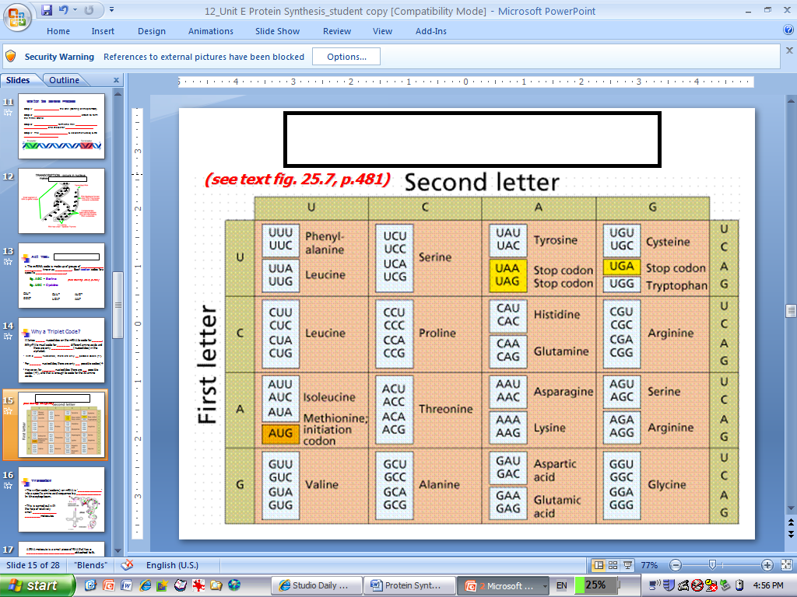The Universal Genetic Code:

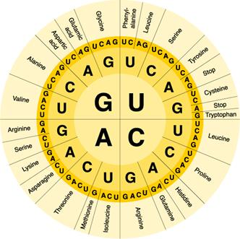

Try it – read the genetic code! ***What is the amino acid for each codon?***

CAU : AUG :

CAU : UGA :

GCC : AAA :