NOTES: MEIOSIS

Mitosis is the process of cell division that allows an organism to create daughter cells which are genetically identical to the parent cell.  This is useful for organisms who asexually reproduce, and also useful to all organisms as they grow and repair their tissues. | Meiosis is the process of cell division that allows an organism to create daughter cells with half the number of chromosomes (haploid) that are genetically unique.  This is useful for organisms who sexually reproduce and need to produce gametes, or sex cells, which will combine during reproduction to form a new organism.
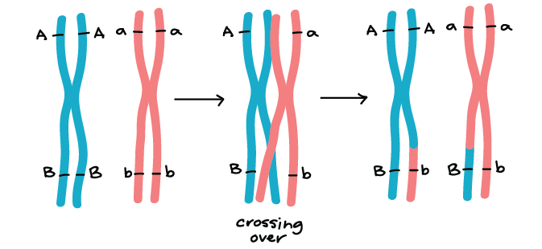
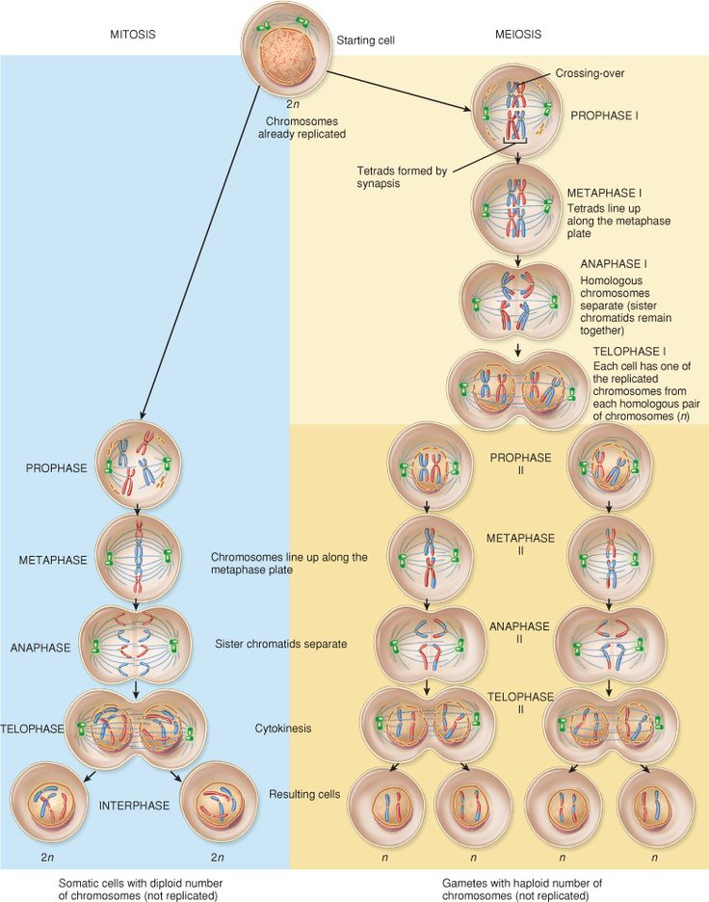
Meiosis creates genetic diversity in two ways:

CROSSING OVER
- During prophase I

- Homologous pairs “clump” together in tetrads, and exchange pieces of genetic information to create unique gene combinations.

INDEPENDENT ASSORTMENT
- During metaphase I

- As homologous pairs line up as tetrads, the “side” each chromosome lines up on is random

