Essential Question: What are endothermic and exothermic reactions?

Demonstration: Baking Soda and Acid Reaction

Predictions
- What are the reactants?

- Predict the products of this reaction.

- Write the reaction equation with the reactants and the products that you predicted.

- Predict what you will observe?

- Explain why you expect to observe what you wrote above.

Method
- What materials are used in this demo? Include quantities.

- In as much detail as possible, write down the procedure for the demo step by step.

Results
- What did you actually observe? Include the actual reaction equation.

- Explain why the reaction happened the way it did to the best of your ability.

In all chemical reactions, energy is either released or absorbed. This energy can take many forms: light, sound or electricity.
Where does the energy to be released or absorbed come from?
When most chemical reactions take place, some ___________ in the reactants must be _____________.
To break chemical bonds, ______________ must be provided.
In order for products to be produced, new bonds must be ___________. Bond formation releases ______________.

One Way to Classify Reactions…All Reactions involve Energy. So, they are either…
Endothermic reactions or Exothermic reactions
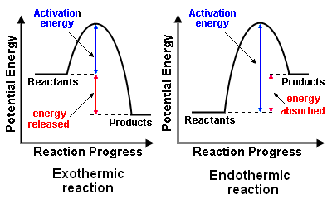
An endothermic reaction is a chemical reaction that requires the _______________
of heat to proceed.
The reaction _______________ heat from its surroundings.
Takes in heat for reaction to occur (feels cold to the touch because it is taking away your heat). This causes a ___________________ in temperature.

Examples:
- Obtaining metal from its ore. (Aluminum metal is obtained by passing an electric current through molten aluminum ore).
- Grilling a hamburger,
- Liquid ice packs (reaction between water and ammonium nitrate absorbs heat)
- Photosynthesis – plants make their own food (chemical energy)

An exothermic reaction is a chemical reaction that requires the _________________
of heat to proceed.
The reaction _______________ energy to the surroundings.
It gives off heat for reaction to occur (feels hot to the touch because it is giving additional heat to you). This causes an __________________ in temperature,

Examples:
- The burning of wood
- the explosion of dynamite and fireworks
- heat packs
- Rusting (proceeds so slowly that it is hard to detect a temperature change.

Activation Energy:
the minimum amount of ___________ that must be applied to start a chemical
reaction. Without this energy being applied, a reaction will ________ occur.

Examples:
- Must apply enough energy to strike a match to start the match tip to burn.
- Gasoline won't burn in air, unless apply heat (spark).

