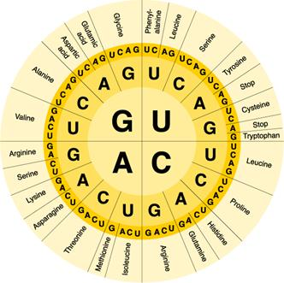

SCIENCE 10 GENETICS DATA SHEET

SCIENCE 10 GENETICS DATA SHEET

